**Deploy a Web Application to Amazon ECS with EC2 | Docker | ECR |Fargate| Load balancer.**

1. **Launched EC2 using Ubuntu 22.04 base image**

Named as (Docker-instance)

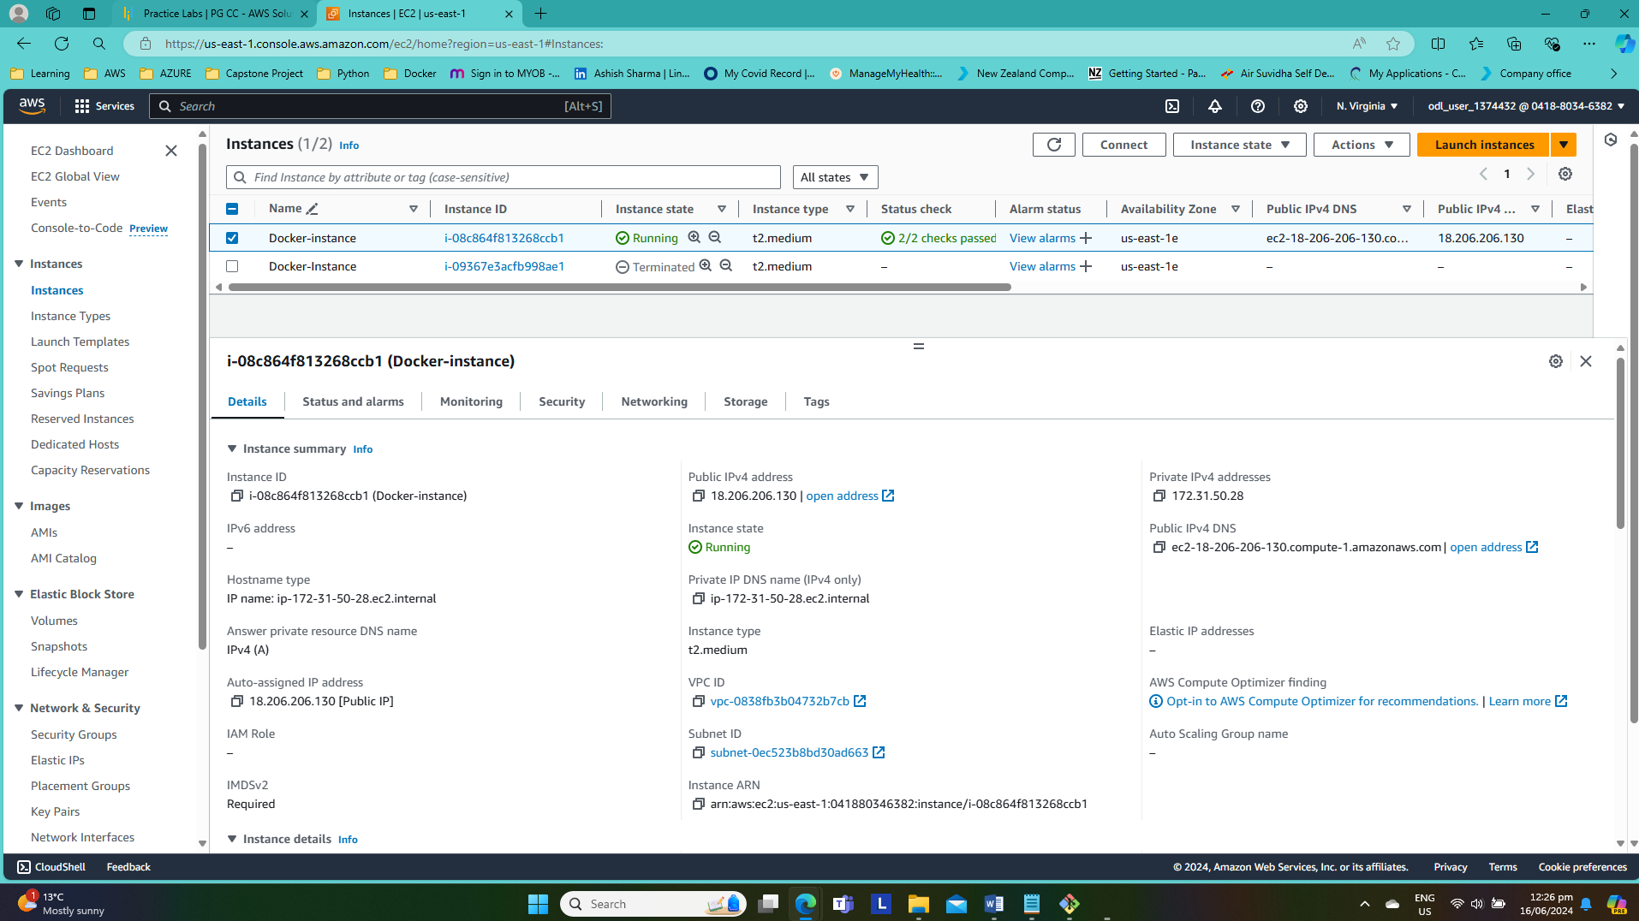

1. **SSH into Docker-Instance using key pair**

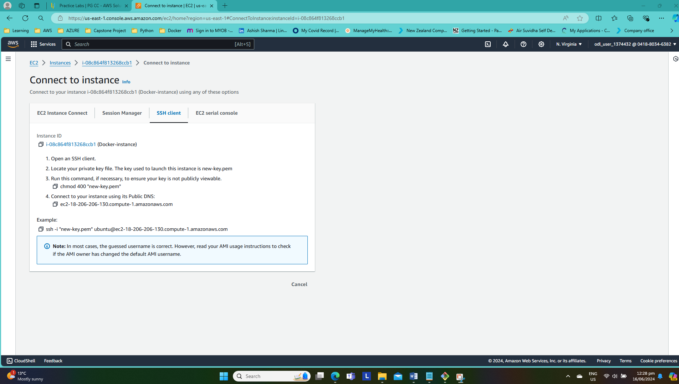

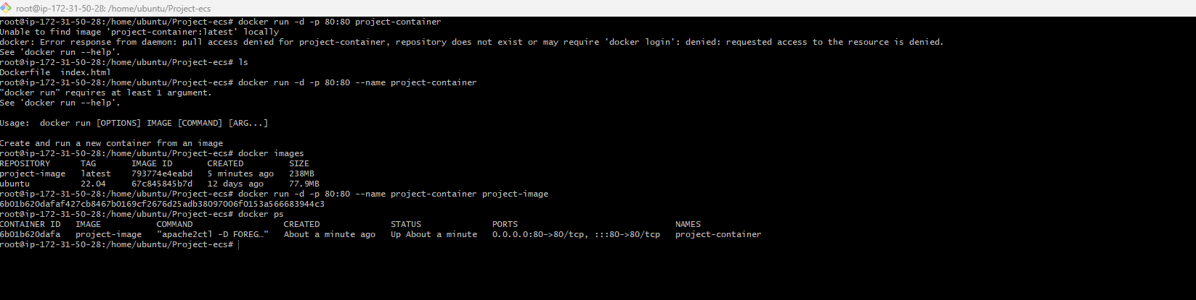

1. **Install Docker using following commands**

-before install docker check for the updates *sudo apt update*

-if any updates are available the run *sudo apt upgrade*

- *sudo apt install docker.io*

-*docker –version*



*-Systemctl start docker*

*-systemctl status docker*

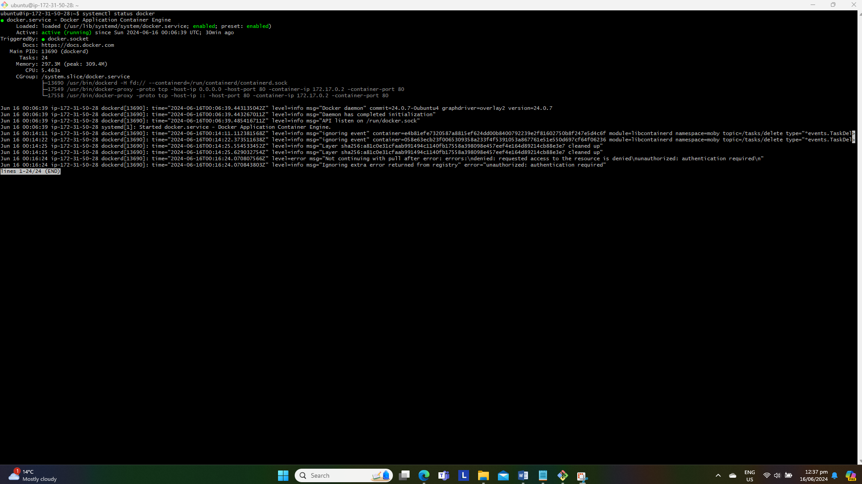

**Build Dockerfile**

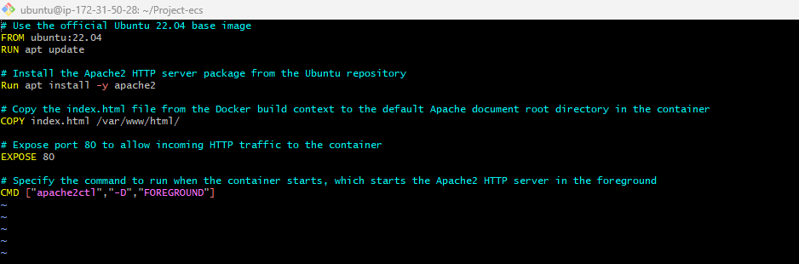

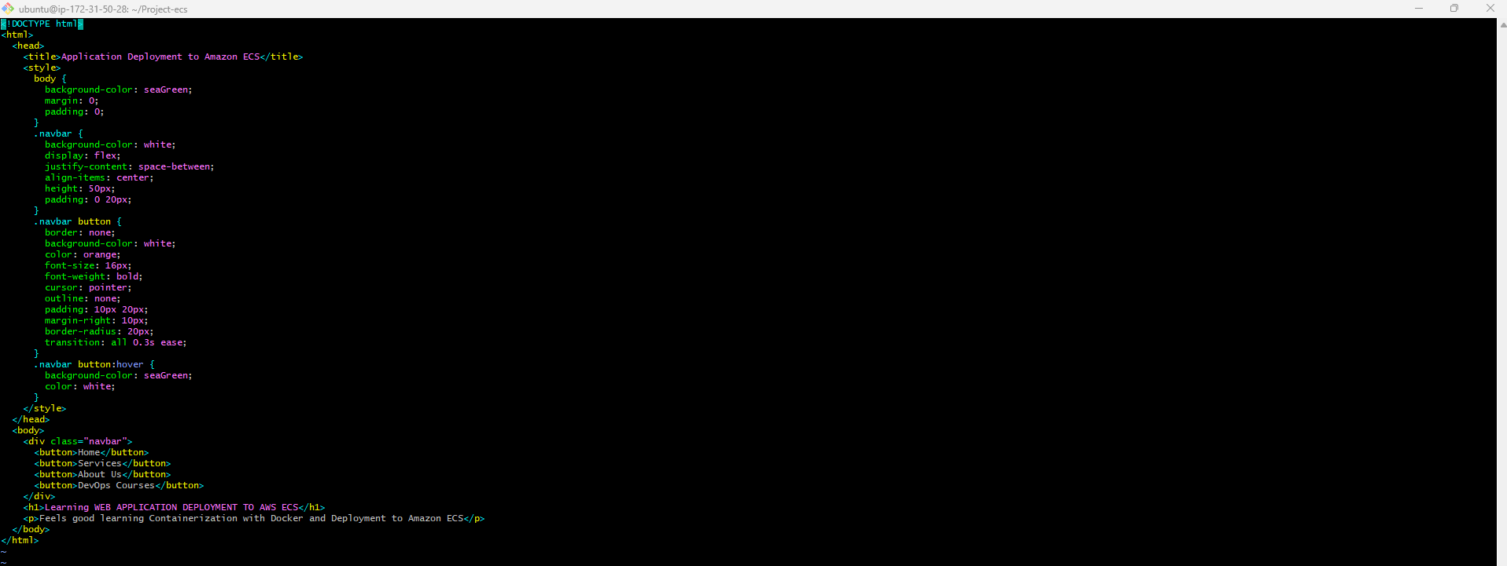

1. **Build Docker image by using following commands**

-docker build –t project-image .

-docker images

-docker run -d -p 80:80 --name (Container Name)project-container (Image name)project-image

-docker ps to check if the container has created

1. **Create a Repository using Elastic Container Registry (ECR) in AWS | Create Role | Attach |Permission**

-Created “projectecr-repo” as private repo.

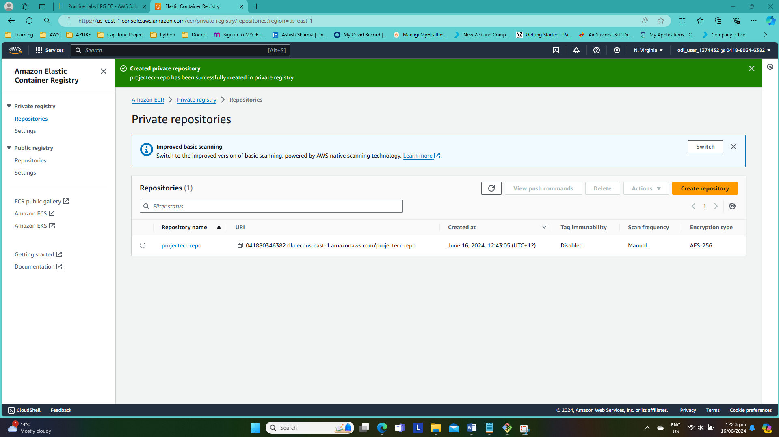

-Created IAM role named as “ecr-role1”

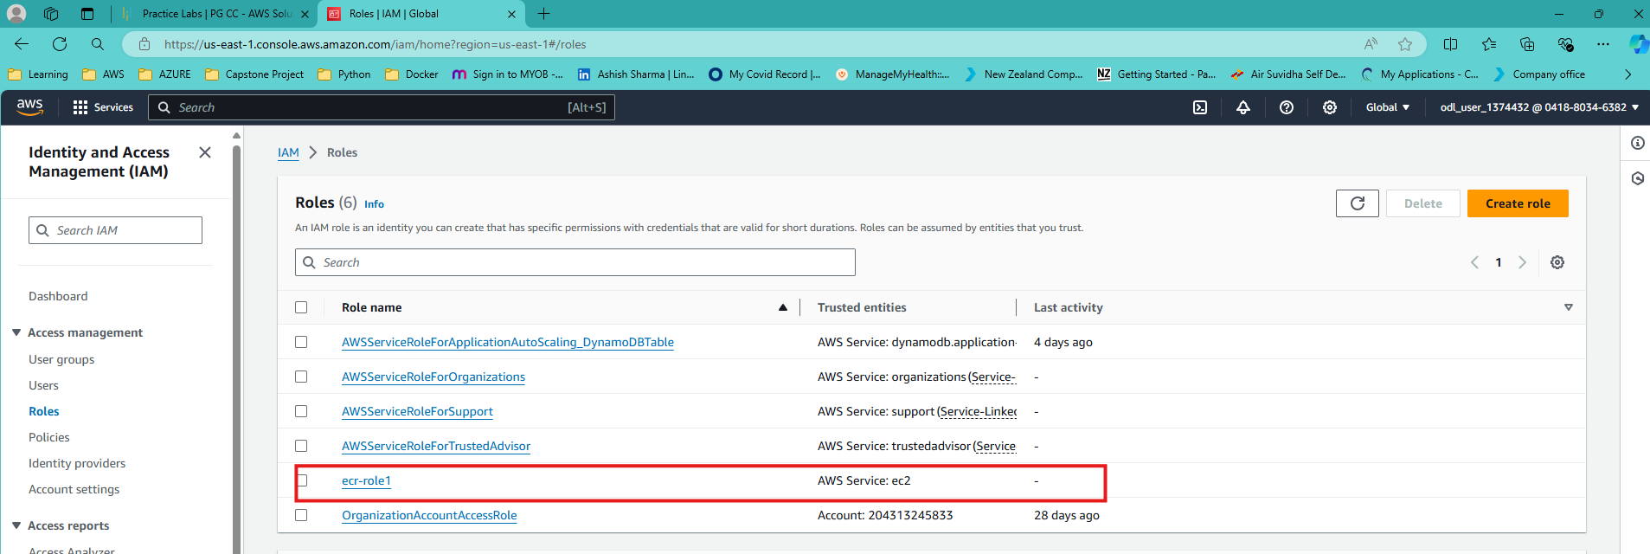

-Attached “Administrator access” permissions to the ecr-role1.

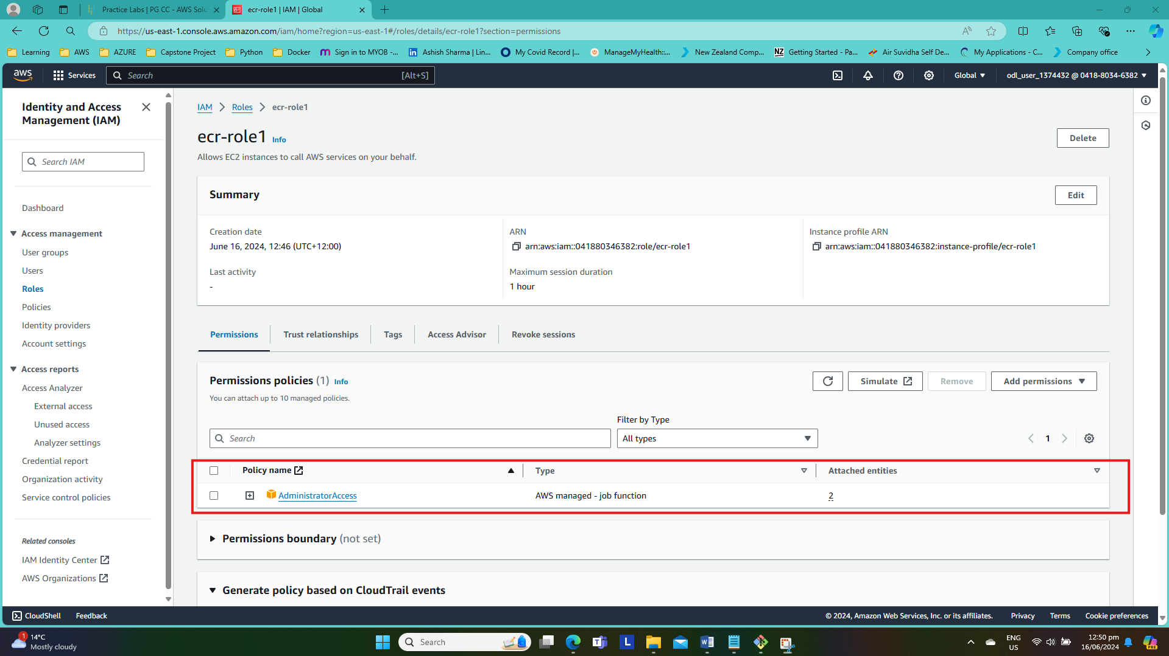

1. **Create Access Key in AWS IAM and configure your credentials. These two keys “access key” and “secret access key” will be configuring our user profile.**

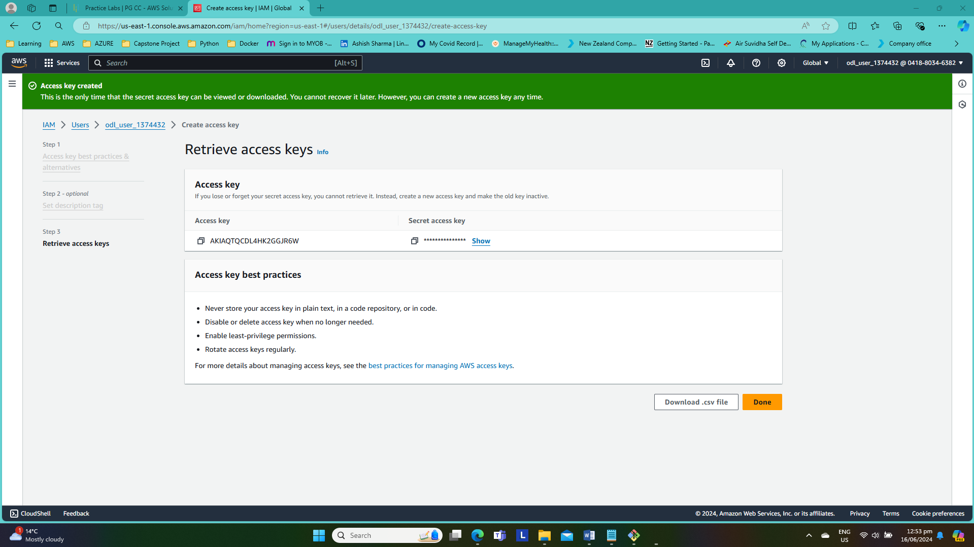

-Download access key and secret access as csv file.

-Check if aws-cli has installed or not if not installed aws-cli first using following commands

*-sudo snap install aws-cli --classic*

*-aws --version*

*-aws-cli/1.16.266 Python/3.5.2 Linux/5.0.0-37-generic botocore/1.13.2*

-in the terminal run following commands to configure access

*-aws configure*

*-enter the access key*

*-enter the secret access*

*-default region us-east-1*

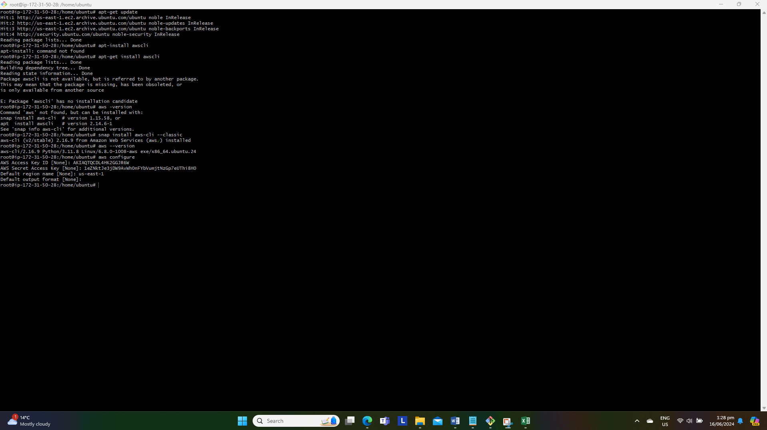

**7. Login to Elastic Container Registry from AWS CLI, Tag the Image and Push your Image to Amazon ECR**

*-Logged into our ECR “projectecr-repo” and will use the following commands to push our docker image to AWS ECR*

*-aws ecr get-login-password --region us-east-1 | docker login --username AWS --password-stdin 041880346382.dkr.ecr.us-east-1.amazonaws.com*

*-docker build -t projectecr-repo* . (This step can be skipped because we already buid an image)

*-docker tag project-image:latest 041880346382.dkr.ecr.us-east-1.amazonaws.com/projectecr-repo:latest*

*-docker push 041880346382.dkr.ecr.us-east-1.amazonaws.com/projectecr-repo:latest*

**We have successfully pushed our docker image to AWS ECR:**

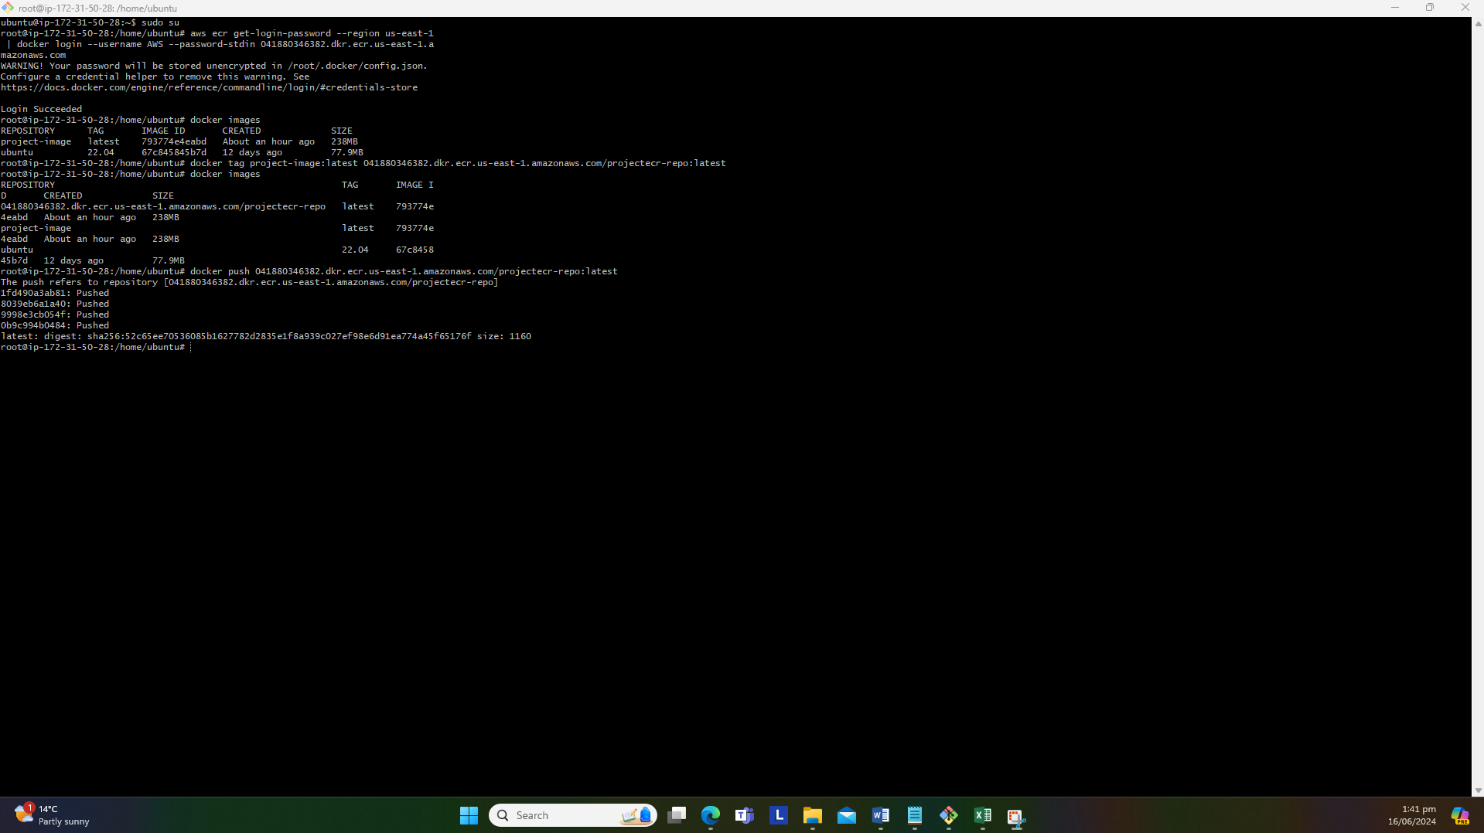

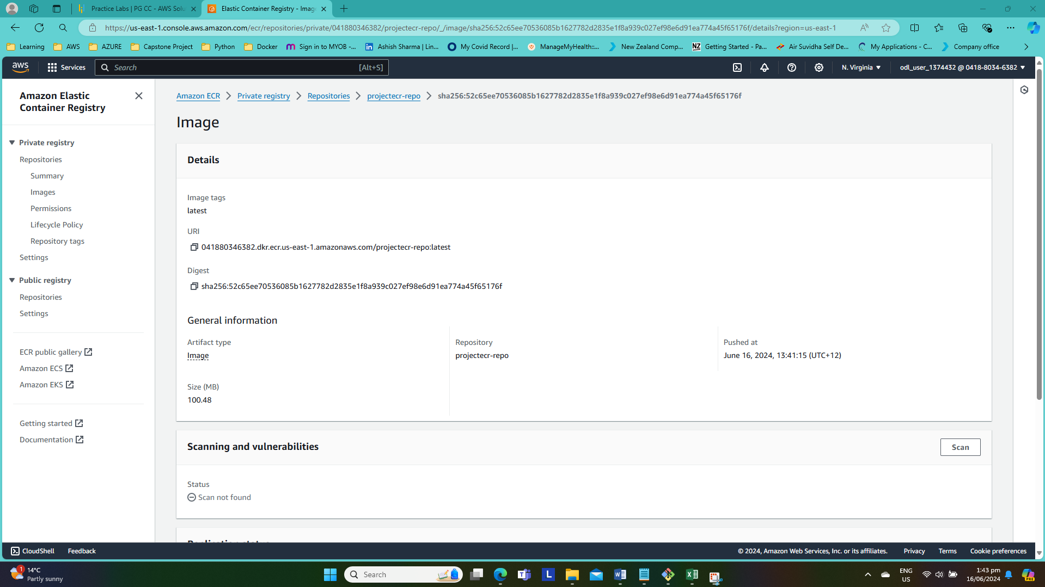

**Create an Application Load Balancer in AWS**

Created Loadbalancer named as “project-internet-facing-lb” with three availability zone to accomplish high availability

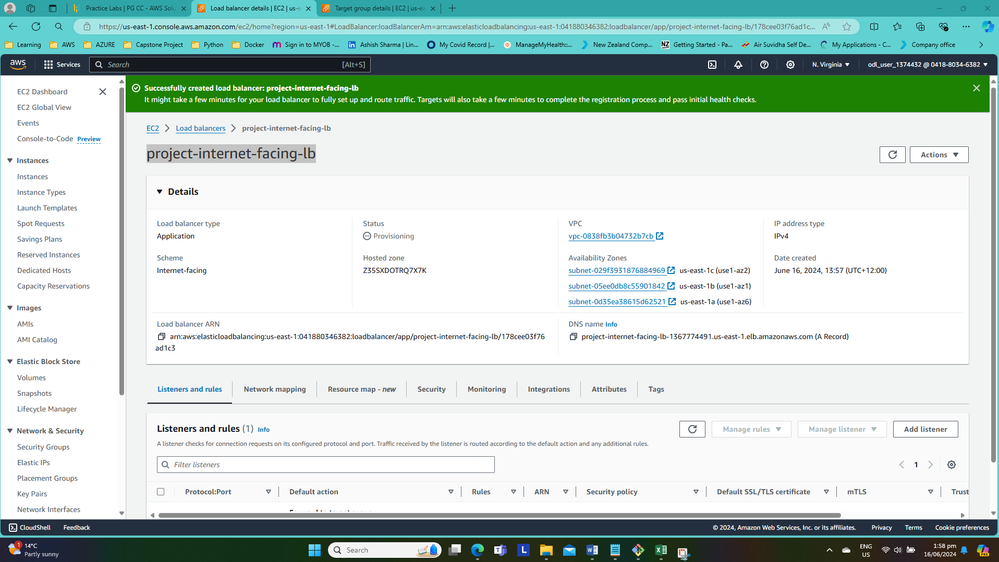

Created target group named as “project-targetgroup”

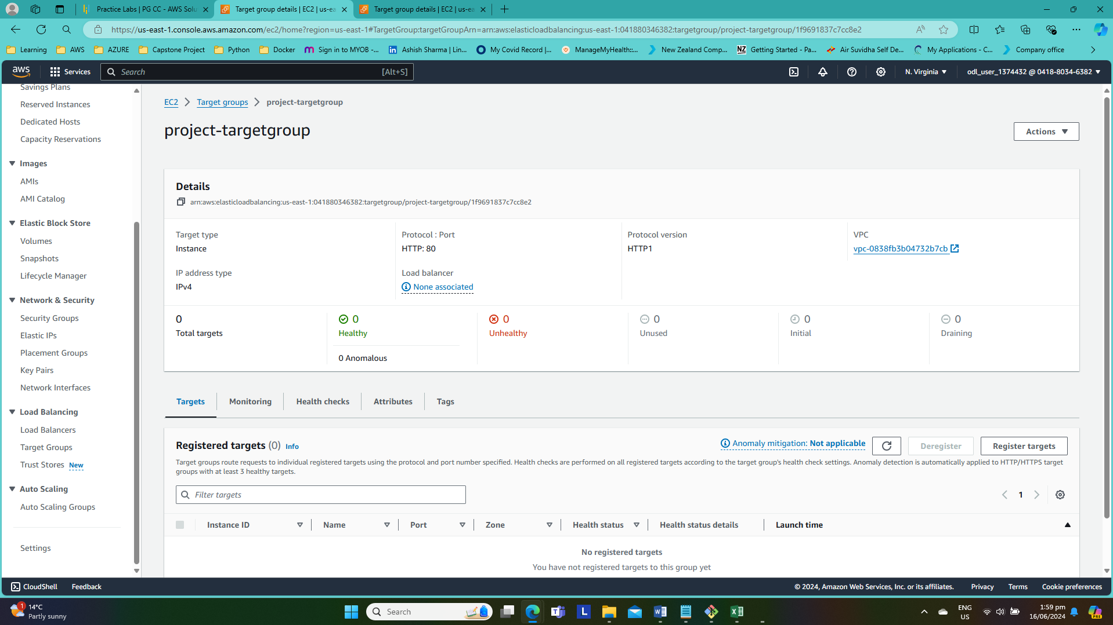

**9. Create Task Definition, Cluster and Service in Amazon ECS | Using Load Balancer in ECS & Validation**

-Created Task definition by using launch type FARGATE.

-Assigned execution “AmazonECSTaskExecutionRolePolicy” role as required for this task

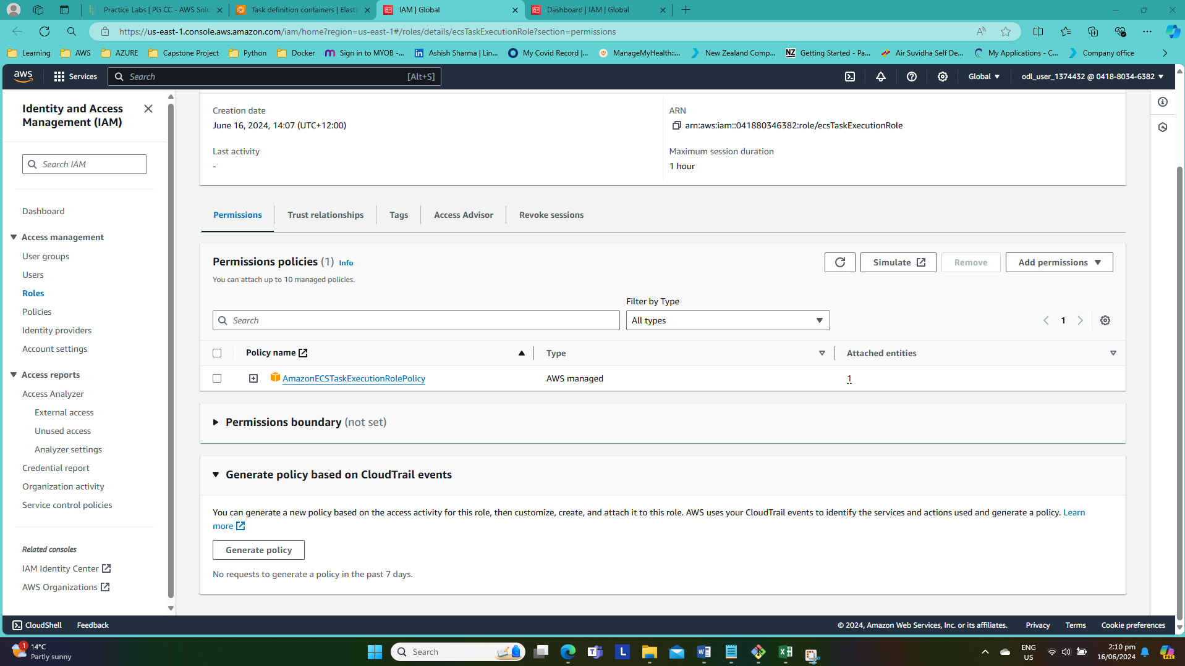

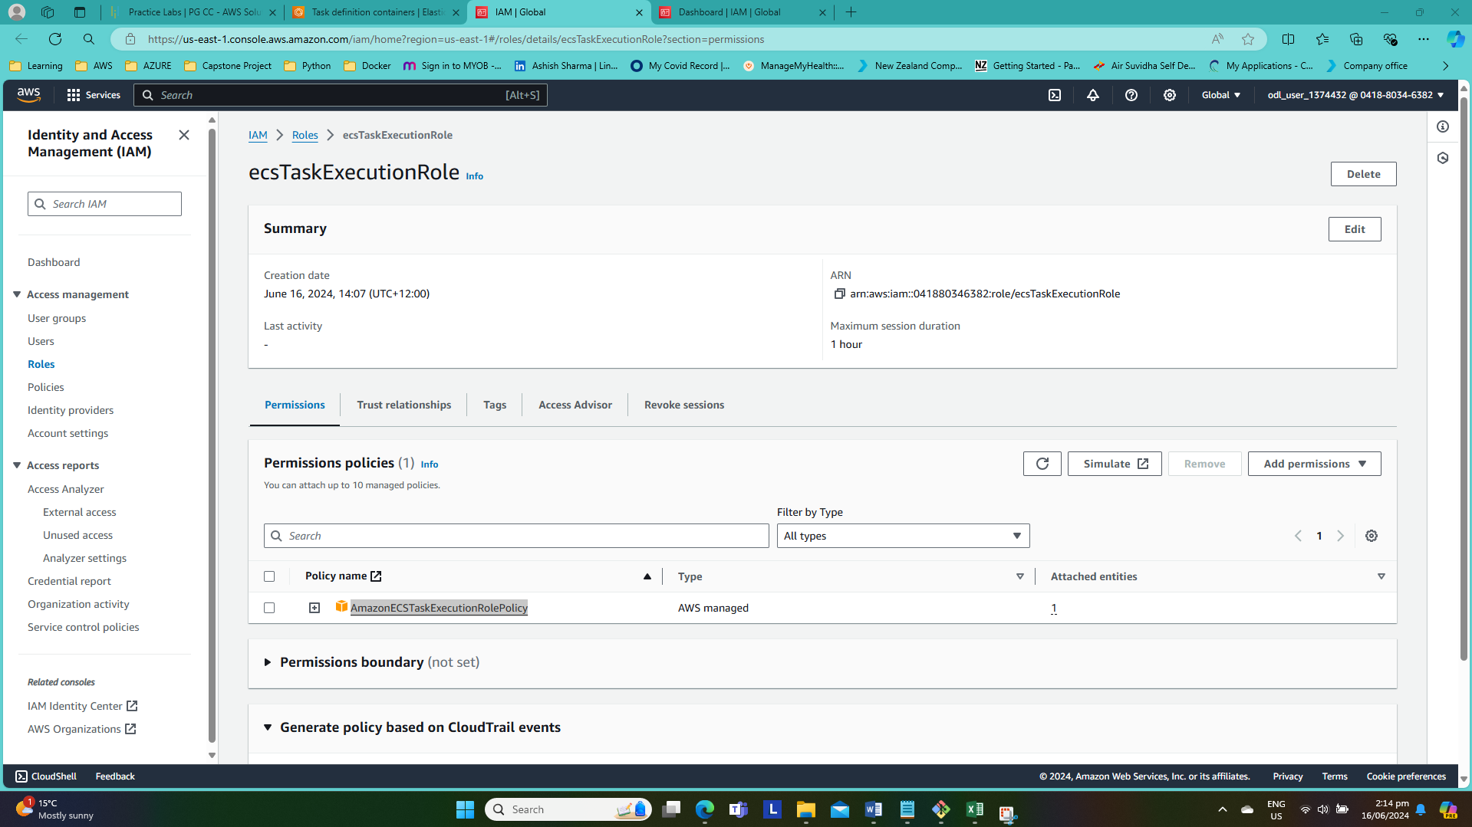

**-Create an ECS cluster**

Created ECS cluster named as “ECS-Project-Cluster1”

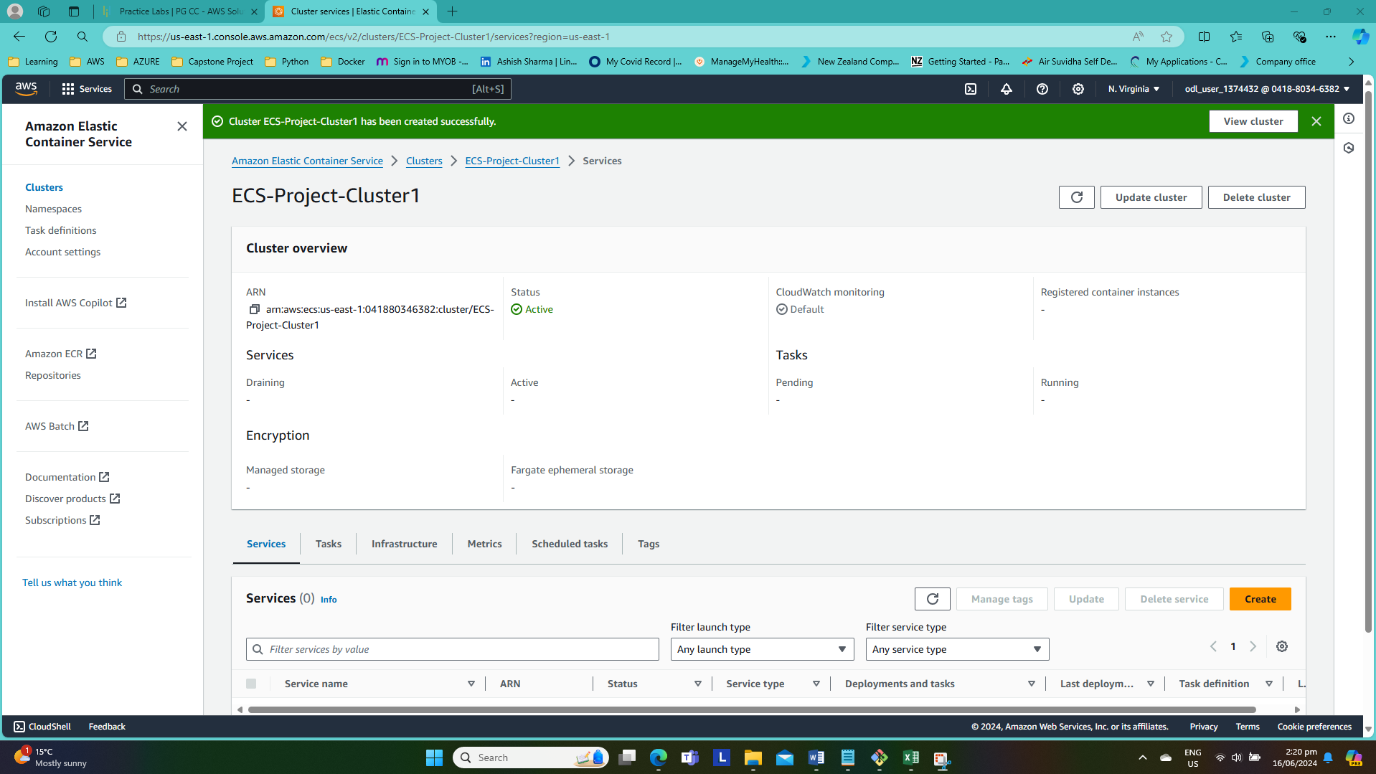

**Create a service:--**

--Created ECS-Project-Service to run two tasks and added to the ECS-Project-Cluster1

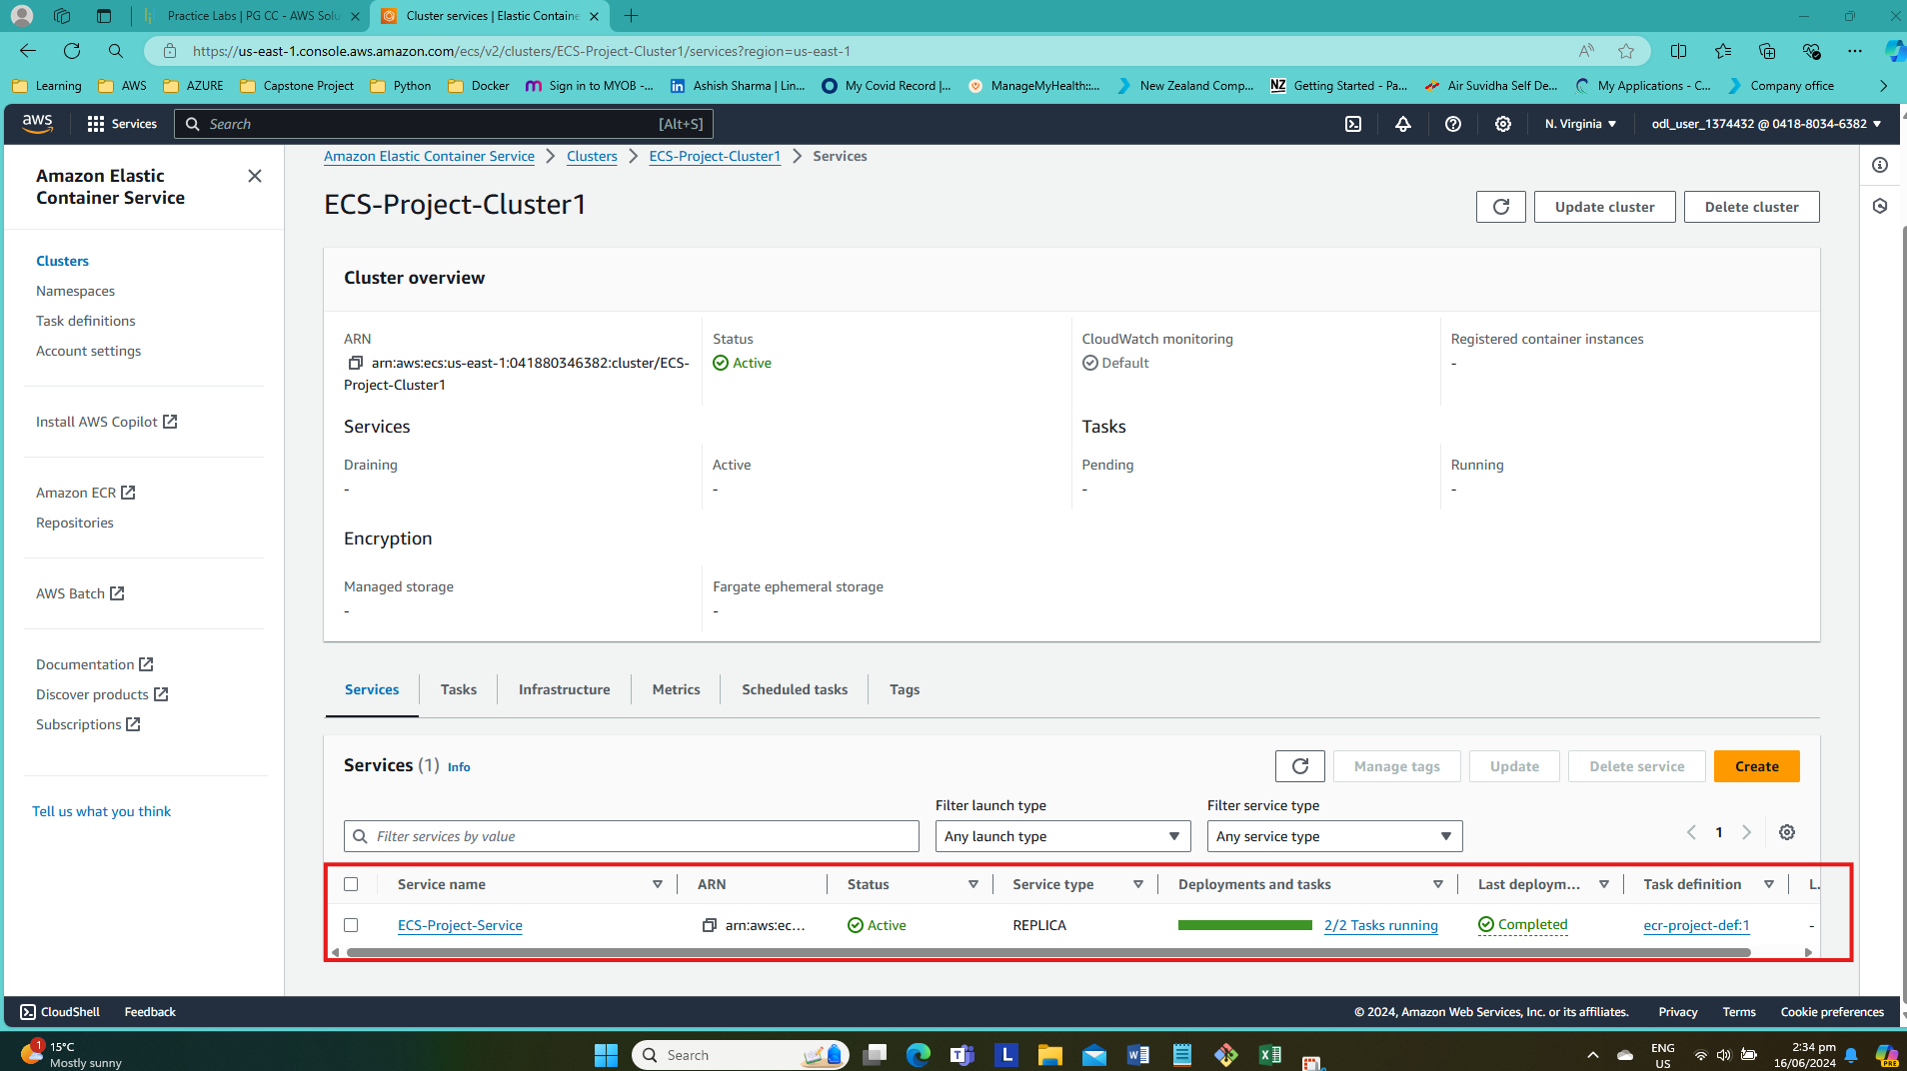

Can see two registered target are healthy and up running

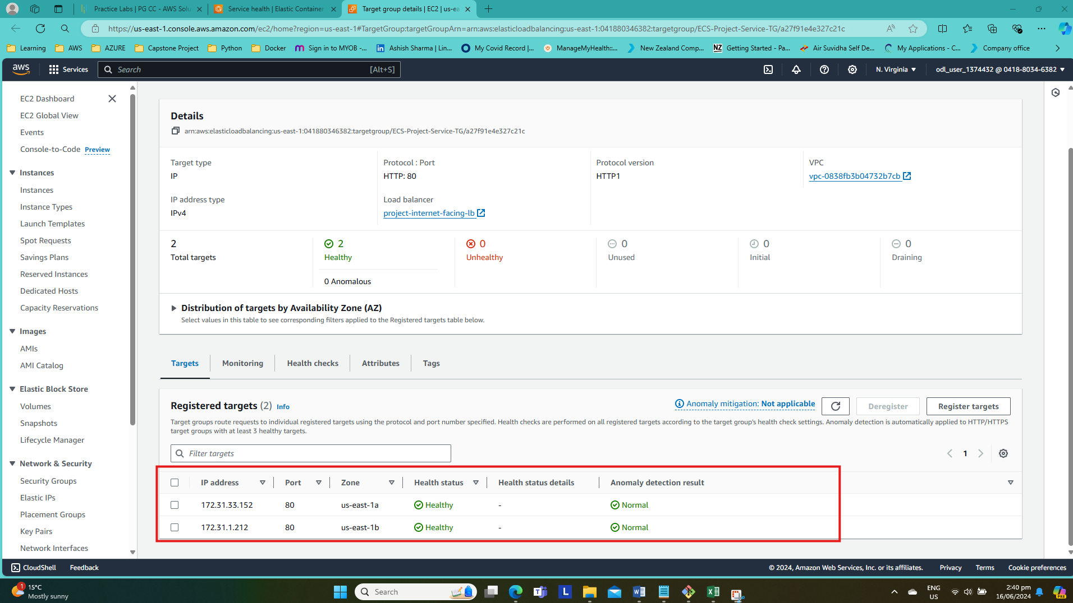

Copied load balancer’s DNS name and tried to access the web application.

Application Deployment to Amazon ECS (project-internet-facing-lb-1367774491.us-east-1.elb.amazonaws.com)

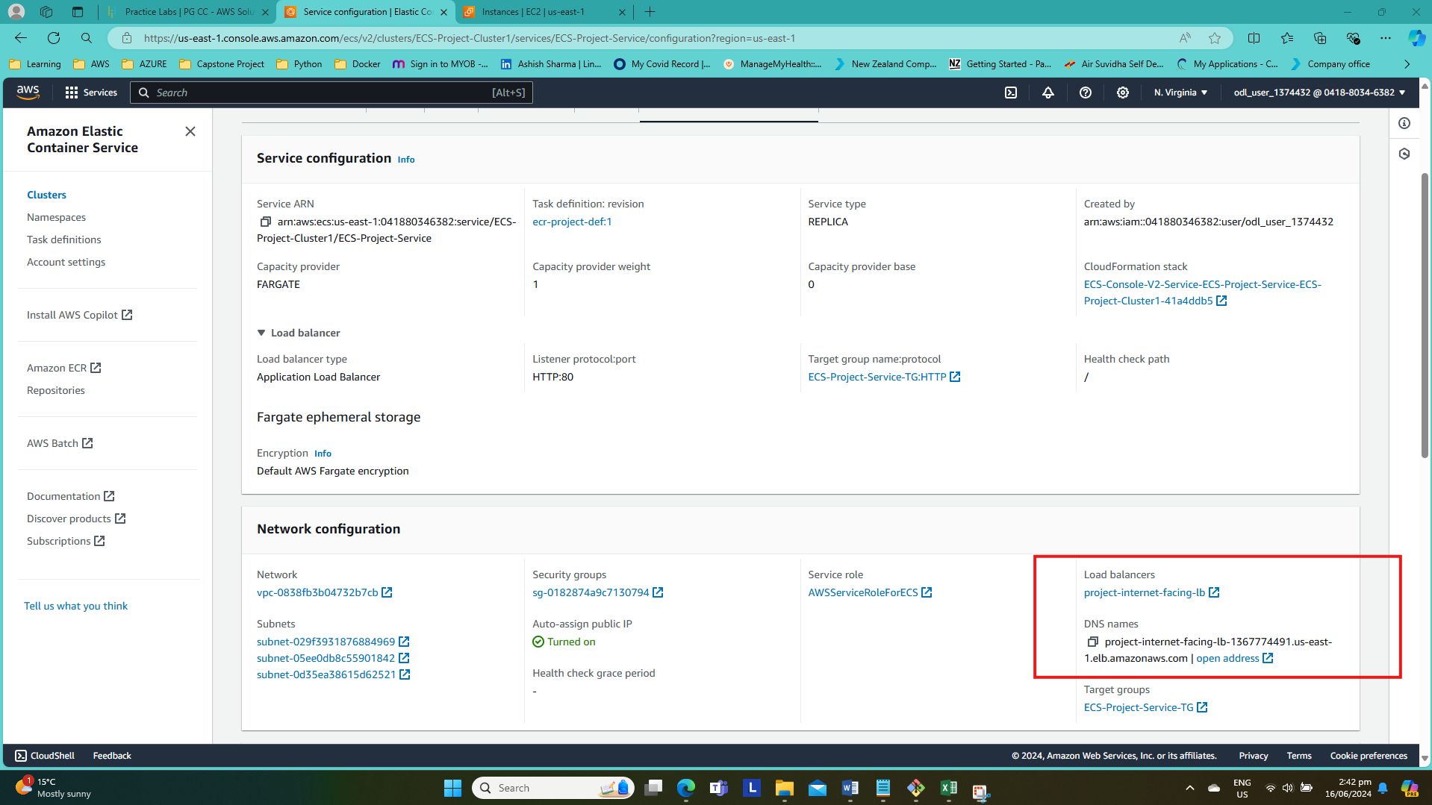

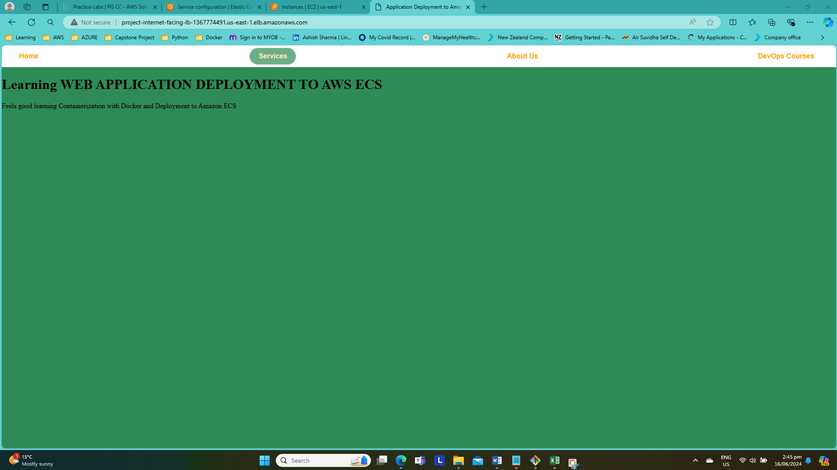

**Refences:-**

[Deploy an Application to Amazon ECS With EC2 | Docker | ECR | Fargate | Load balancer | AWS Project (youtube.com)](https://www.youtube.com/watch?v=6Hj-stf51Bc&list=PLqoUmUbJ_zDHPwK-ZWATXiYrUXwWkLY65)

[containers-aws-ecs/Dockerfile at main · Tech-With-Helen/containers-aws-ecs (github.com)](https://github.com/Tech-With-Helen/containers-aws-ecs/blob/main/Dockerfile)

[How to Set Up Apache in a Docker Container on Ubuntu 22.04 | by donfiealex | Medium](https://medium.com/@donfiealex/how-to-set-up-apache-in-a-docker-container-on-ubuntu-22-04-77b5a11ef817)

[software installation - How to install awscli on Ubuntu 18.04? - Unix & Linux Stack Exchange](https://unix.stackexchange.com/questions/561236/how-to-install-awscli-on-ubuntu-18-04)